Our Poppy Filled Week!
We have had a very busy week of transition this week. The children seemed very excited to meet their teachers and the teachers all had a very positive session with their new class.
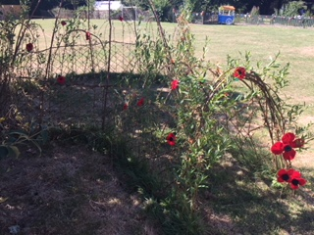
I am very impressed with the new reception children – I do not think we will have any issues with them settling in September!
Thank you to Mrs Hobson and Miss Youds for delivering their transition meetings this week. They were very well attended and we hope that the packs will be useful to you.
We also sent home information for new Year 2 parents this week and junior information will be sent out before the end of the year.
On Tuesday morning we had our Rugby in Bloom judging. The judge was impressed with our grounds but I will not know the outcome until later this month. I will keep you posted!
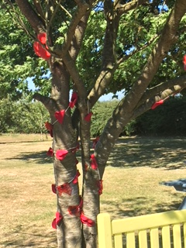
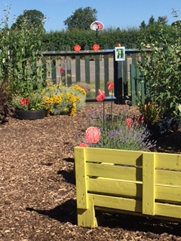

Sports day and Family Picnic
Hopefully you have receievd a separate letter from Miss Youds detailing the arraingments for our Sports day and family picnic on the 11th July.
Please note that this year the children may wear a T-Shirt in their house colour.
We look forward to this exciting event next week. If you do not have a letter, please ask Mrs Davenport for a spare one.
Reception Graduation
This is taking place at 2pm on Friday 13th. Parents and family members of the reception children are welcome to attend.
School Disco and Leavers BBQ
This PTA event is taking place on Friday 13th too from 6pm to 8pm (all children) and until 10pm (not 9:15 as stated previousy) if staying for the leavers BBQ. If your child is in Year 5 or 6 Miss Haley has sent out a separate letter detailing the event.
Leavers T Shirt and Autograph Book
Miss Haley has organised these for the Year 6 children this year at a cost of £10 for both items. The children will also receive their hoody which is paid for by the PTA. If you would like your child to receive a special T Shirt and autograph book, please bring in your money asap. Thank you.
Awards Assemblies – 17th July
Every child receives a certificate at the end of the year and this is celebrated in front of their class. You are welcome to attend if you are able.
Approximate timings are as follows:
Year 1 and 2: 9:15 to 10:00
Year 3 and 4: 10:00 to 10:45
Year 5: 11:00 to 11:20
These are approximate timings.

Year R and Year 6 will receive their certificates in their graduation/leavers assemblies.

Main Summer Term Dates:
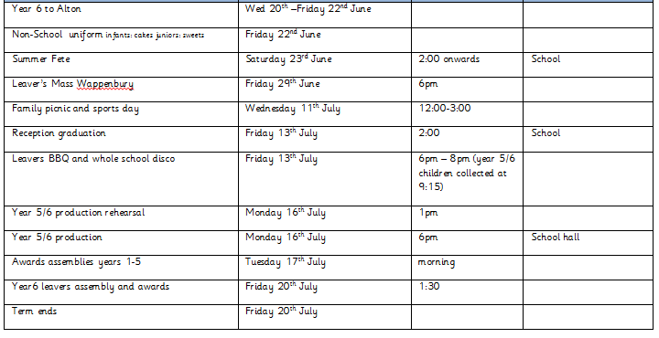

Week beginning 9th July:
Monday 9th July
Mission assembly
Wednesday 11th July
Sports day and family picnic (see separate letter for details)
Forest School
A reminder that the last session for forest club is now Wednesday 11th July.

Friday 22nd June

Friday 13th July
2pm Reception graduation

6pm – 8pm Disco followed by leavers BBQ (pick up 10pm)

Have a lovely weekend, Kate Madia

Have a lovely weekend

Kate Madia

