Our Week

What a seven days it has been!

The Year 6s arrived back safely on Friday late afternoon looking very sleepy from their residential! They had a brilliant time together and were a credit to the school and their families.

At the same time as the arrival we had lots of parents on hand to set up for the fete which was a roaring success. The atmosphere was great and is was really wonderful to see families both past and present. Once again a huge thank you to the PTA and all others who helped to make the fete a success.

On Tuesday we had ‘the best day ever’ according to many of the children. All the children experienced a planatarium, the ‘animal man’ and had a visit from the ice-cream van to top it all off! A day to remember, that’s for sure. John, the animal man commented that he had never been to a school where the children were so polite and well 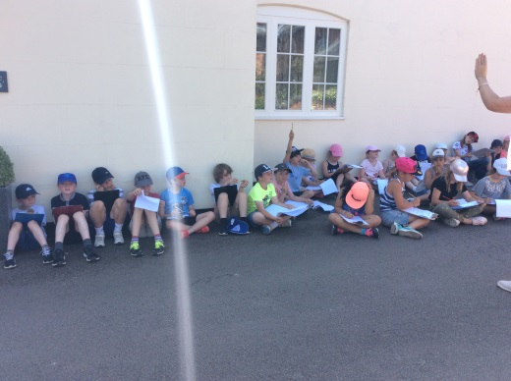behaved.

I had the pleasure of accompanying the Year 3 and 4 children on their Princethorpe geography field trip in the afternoon – they learnt a lot, collecting a huge amount of data on the area.

Year 5 and 6 have been rehearsing their play this week, year 6 have also had some of their transition days for their secondary schools. I have heard lots of positive reports. Well done.

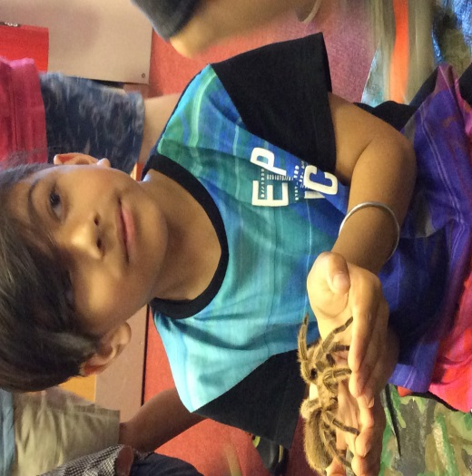Attendance this week:

Whole school 98% ☺ this is excellent!

After School Forest School Club

Mrs Ellis is unable to attend school next Wednesday 4th July. Therefore the final session for this club will now be Wednesday 11th July. I would like to take the opportunity to thank Mrs Ellis for providing this club – the children are loving it.

Music Tuition – violin and piano

If you wish your child to continue or commence lessons in violin or piano/keyboard, request forms should have been back with us today.

If you still need to send yours in, please do so by Monday 2nd July or see Mrs Davenport if your child did not bring a letter home with them. We will be finalising the timetable with Mr Roe next week, so please do not miss out.

Big Spell

The final big spell for this year will take place on Tuesday. Please make sure that the children a final look over their lists

Times Tables

It is so key that your children know these, particularly as they move into the juniors. It really slows the chidlren down if they are not able to quickly recall tables facts. By the end of Year 4 the children should be fluent with all their tables up to 12 X 12. Any work that you are able to do at home will be greatly appreciated.

Leavers Mass and social

This is taking place this evening at 6pm at St Annes Wappenbury. Drinks will be served on the terrace afterwards. All are welcome. Please do not park in the carpark however as the tarmac is melting from the heat. Please park on the road leading up to the church. Thank you.

Rugby in Bloom

We are being judged for the annual Rugby in Bloom on Tuesday morning. We still need poppies and lots of them! Please, please do get creative this weekend – knitted, paper, plastic – it doesn’t matter! The theme is WW1 so we are looking forward to transforming the grounds on Monday! Thank you in advance.

Leavers BBQ and Disco

Friday 13th July

The finish time for the Year 5 and 6s is back to original time of 10pm.

The whole school disco starts at 6pm.

Family Picnic and Sports Day

This is taking place on Wednesday 11th July.You should have received a separate letter about the arrangements earlier on in the week. Please ask Mrs Davenport for a letter if your child has not bought one home.

Week beginning 2nd July:

Monday 2nd July

Sports Day Assembly

Please bring in poppies if you are able

Tuesday 3rd July

Big Spell

Rugby in Bloom judging

Wednesday 4th July

Transition Day for the children

Transition meetings

Have a lovely weekend

Kate Madia

Main Summer Term Dates:

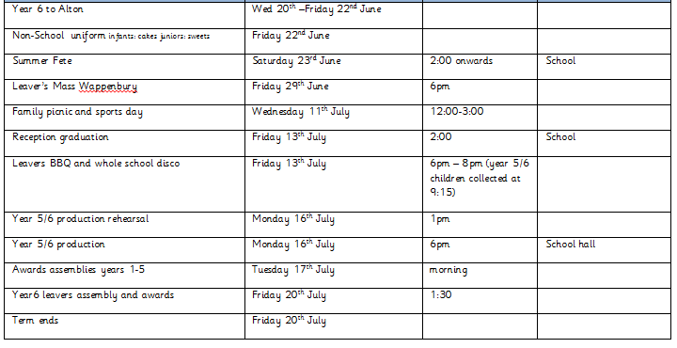

**Have a lovely weekend**

**Kate Madia**

A couple of reminders:

Please communicate with teachers via diaries or Class Dojo if in the juniors, if your child is going home with someone other than their own parents.

Please make sure that younger children are arriving at the school gate safely. The road is not a safe road and I have been made aware of little ones being dropped off on the road and asked to walk up by themselves.

Children should not be wearing nail varnish please and hair should be tied back, this includes boys with hair long enough to tie back.