Holidays during term time, as you know, are not allowed, unless for exceptional circumstances which are agreed, beforehand, by the head teacher.

I am very disappointed that some parents do not seem bothered by this rule. Fines will be given to those parents who are not following guidance and conversations about any unauthorised absence will take place with the Headteacher or Office Manager. These conversations will be noted and submitted as part of the referral to the ACE service at the LA.

It is also unacceptable that certain children are continually late. It disrupts the learning in the morning. If you are constantly 5 minutes late, please leave 5 minutes earlier; there really is not excuse.

Fete
I have so many people to thank for the success of the fete – from the PTA to those who volunteered to run stalls. You many of you generously gave your time to help raise money for our school and I am humbled by your committed and passion for our little school. It was a wonderful day and we were so lucky with the weather! I know that the PTA will fill you in with details of the success of the day in due course.

Reminder Children should not wear nail varnish to school and long hair must be tied back.

St Peter weeping before Our Lady
Thank you to Year 5 and 6 girls who sang so beautifully the words of St Paul – ‘Without Love’. A wonderful celebration of two very special people.

Year 6 Alton Castle Retreat
This is fast approaching and the children are getting very excited! Please make sure you read all relevant paperwork so that you are adequately preparing the children for the few days that they are away.
Year 5 will be taught by Mrs Madia whilst Miss Haley is away.

Relationships and Sex Education Programme
Year 5 and 6 parents will have received the policy detailing the Relationships and Sex Education Programme which also detailed the parent meeting that took place. The programme will start once the Year 6 children are back from Alton.

Choir to Princethorpe
This Thursday 34 children have been invited to sing at the Senior Citizen’s Summer Lunch. The children have been working hard on their songs and sound fantastic!

Who has been Faith-filled and Hopeful this week?
Inspire Day
On Monday 10th July, we would like to invite Year 3 and 4 parents in at 1:30 to work with their children to create some artwork around the theme of ‘light’. This work will then be presented and blessed at church on Sunday 16th at 10:15. Please could you indicate through class dojo or through the home/school communication book if you are able to attend so that we can prepare for numbers.
End of Year Celebratory Masses
Year 6 Leavers Mass – Thursday 20th July 6:30 at Wappenbury
Whole School Mass – Friday 21st July 9:15 at Our Lady’s School

Awards Assemblies for Year 1,2,3,4 and 5
These will take place on Tuesday 18th July. These timings are approximate, but will allow parents to stay for children in other year groups, so that they are not having to take more time out of work.
Year 1 and 2 – 9:00 – 10:35
Year 3 and 4 – 10:35 -11:05
Year 5 10:30 – 11:05 – 11:30
Reception Graduation
Thursday 20th July 2:00
Year 6 Leavers Assembly and Awards
Friday 21st July 1:30
Optional Drop in for Parents following End of Year Reports
Wednesday 19th July 3:30

First Holy Communions
Please continue to pray for the children who have received their Sacrament:
Fintan
Sofia
Molly
Verity
Naomi
Eve and George

Sports Day and Family Picnic

You are welcome to bring a picnic along to our Sports Day on Wednesday 12th July from 12.30pm. Races will begin at 1:00. Refreshments will be available to purchase.

Warwickshire CC Music

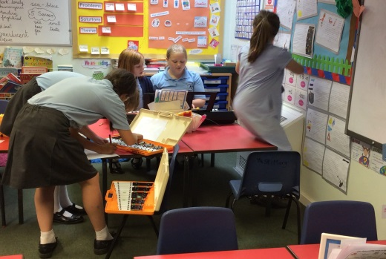
Warwickshire Music will not be continuing in September. Unfortunately, we are unable to subsidise the lessons as we have done in past, for the 16% of the children who participate. Alternative arrangements are currently being explored. Thank you for your understanding in this matter.

Art Gallery

Please come along to our Art Gallery on 29th June 3:00 – 4:45. There is no obligation to buy.

Please see the separate letter detailing this.

Athletics

Our Rugby Athletics is taking place this Friday 30th. The children know who they are if they are going to represent the school and have been working very hard. I’m pretty sure we’ll be bringing home some gold medals again this year!

Next week at a glance:

Monday 3rd July:
Mission Assembly – parents welcome
Year 6 to Alton

Have a wonderful week
Kate Madia

Year 5 and 6 have been composing music and have been learning to use notation.
