It has been a really busy half term again! The children are tired and looking forward to a break so I hope that you are able to have some quality family time together and that the weather is favourable!
Travelling Books - Book Fair

The Travelling Books book fair is visiting our school after half-term! The fair will arrive on Wednesday 8th June and run until Wednesday 15th June. We will open the fair to children during break times and lunchtimes. There are some exciting titles available and a 'buy three books get the cheapest book free' offer! To look at the titles available please go to www.travellingbooks.co.uk. The book fair offers another chance to support our school library; the commission will be spent on further resources to supplement our school library. Thank you in advance for your support.
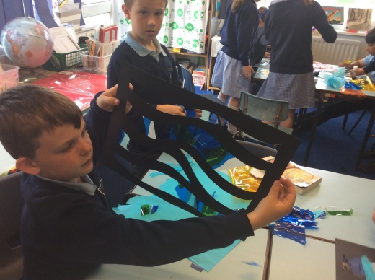

Teacher Training Day
This half term finished today: Thursday 26th May. Please do not send your children to school on Friday 27th!
The children return to school for the final half term on Monday 6th June.

Attendance
This week’s attendance: 96%
This is above our target this week…

School Meals

Parents who pay half termly for school dinners should looks out for the blue slip in children’s bags on Thursday 26th May which will advise on the correct amount for next half term, taking into account any credits due and school trips.

Lates
I am noticing children getting to school late. I understand this if it happens occasionally and if there is good reason, but there are some children who are repeatedly turning up past 9:00. This really is not good enough. Lates have been checked thoroughly and if your child has had a number of late marks then you will be receiving a letter from me which urges you to get your child into school on time. It is very disruptive for all involved when a child comes in late and it is not fair on the child who is coming into lessons late.

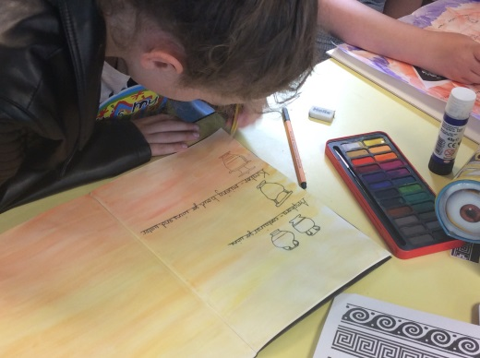

Woodwind lessons

At the moment we only have one child wanting lessons in September. If anyone else is interested can you please contact Mrs Davenport before half term. It is a wonderful for children to learn an instrument – please do consider this opportunity.

Sports Day

Please do join us for our sports day on the 16th June. If you would like to come along at 12:30 for a family picnic, please do – it will lovely so long as the weather allows it! The races will start at 1:30.

We are inviting all new reception parents and their children too. More information to follow.

Non-uniform Days

Thank you for all the donations today of bottles for our school fete, we were overwhelmed by the amount! These will make all the difference for our fete!

Our second non-uniform day will be on Friday 24th June, where we would like to ask you to donate cakes, if at all possible, for the refreshments stalls at the fete.

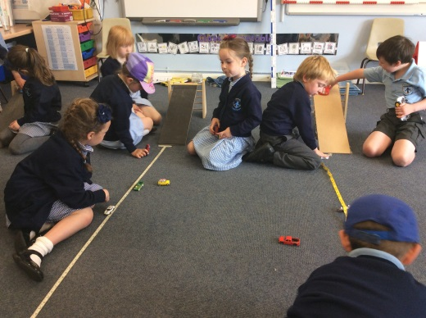

The Tempest

The Year 5 and 6s are getting excited about their end of Year production of William Shakespeare’s ‘The Tempest’.

The performance will include all the children in Year 5 and 6 and will take part on:

Monday 18th July at 6pm.

Please save the date.

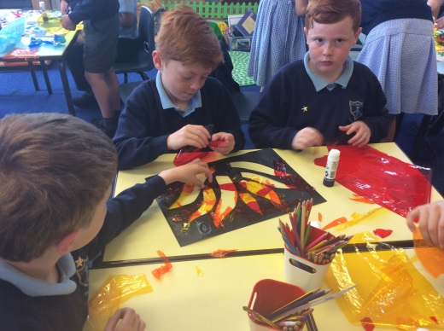

Family Mass Dates

This will take place up at Princethorpe Chapel:

26th June
17th July

It was lovely to see so many of you at the last Mass. I look forward to seeing you there.

Leaver’s Mass – for all Year 6 children 13th July

Next week at a glance:

Monday 6th June
Mission assembly – parents are welcome
9:15

Tuesday 7th June:

Big Spell

Wednesday 8th - 15th June:
Travelling Book Fair

Year 6 to Alton until Friday

RUN A MILE DAILY
REMEMBER TRAINERS

Have a lovely half term weekend

Kate Madia

