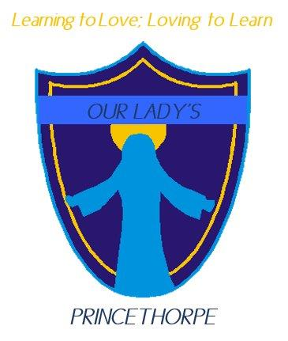
Governor Newsletter March 2024
From the Chair – Peter Griffin

Dear Parents
We are acutely aware of the difficulties you have faced this term when we have had to respond at short notice to incidents of flooding, either before the start of school in the morning or during the school day. We are actively engaged with Warwickshire Flood Management Team, the Highways authority, Princethorpe Parish Council, Princethorpe College and the police to establish clear procedures if and when there is another incident. Obviously, the priority is to prevent flooding if possible and we are optimistic that the above agencies should be able to take steps to reduce the risk. However, being realistic, it is highly likely that there will be incidents in the future which would require us at Our Lady’s to take steps to respond in an emergency. While we are committed to doing what we can to keep the school open our ultimate obligation is the health and safety of our children and parents. We also have to be very conscious of any potential liabilities on the school or the governing body should anything unfortunate occur as a result of parents, staff or children following our guidelines or instructions. For these reasons we are not as yet in a position to finalise policies or guidance and ask for your understanding whilst we strive to put measures in place.

Flooding and a detailed consideration of the latest diocesan plans for education were high on our agenda at our full governing body (FGB) meeting on Monday (18th March) so it was a welcome relief to hear of the decision of the PTA to help finance the purchase of much needed new chairs and tables for our children. I’m sure you are all aware of the constraints on public expenditure so we are extremely grateful for the wonderful fund-raising undertaken by our very active PTA. We welcomed Cyp Vella, Head of Religious Studies at the College, as a new Foundation Governor; Cyp’s expertise should be invaluable as we prepare for a Catholic School Inspection (CSI) from the diocese, possibly as soon as next term. We also bade a fond farewell to Dave Maceluch, who has been an outstanding School Governance Professional (clerk) to the GB for the last 8 years.
The PTA’s next big event is our annual duck race on Saturday 13 April, commencing at 11.00am. We’re hoping the water level in the brook will be perfect for a good race! Spring is very much in the air and the daffodils have been in bloom with the border between the brook and the school fence putting on a good show. There is plenty of space for a range of perennial bulbs and shrubs still to be planted to make these borders on either side of the school entrance a real all year round showpiece and I would encourage you to donate plants or seeds which we can sow in this area. Perhaps we can do this on the morning before the duck race – just bring a trowel, fork or spade and join in the fun!
The last few days of every term are always frenetic with activity; I was pleased to be able to join the children on their Lenten walk on Tuesday afternoon raising a significant sum for their chosen Lenten charity. Fr Teddy and I joined parents and governors at the soup lunch on Wednesday and I was also able to join the children on the ‘Stations of the Cross’ on Thursday morning before popping into school to see the Easter bonnet parade – a fitting and exciting end to a hectic term.

As always, I want to pay tribute to the professionalism, dedication and commitment of all the staff who work tirelessly in the interests of your children. Under the inspired leadership of Mrs Burch, who has now completed a full year in post, the school goes from strength to strength; it is so reassuring for governors to hear how much parents appreciate all that the staff do for your children.
Best wishes for a lovely Easter vacation and if you’re travelling stay safe (and dry!)
Peter Griffin
Chair on behalf of Our Lady’s Governing Body

